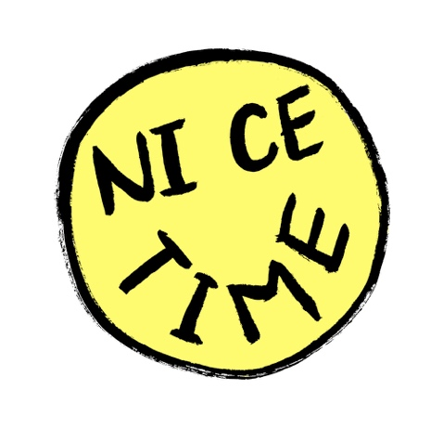
REGISTRATION FORM – COHORT 1

PREFERRED NAME:

__________________________

FIRST NAME: ____________________________________

LAST NAME: _____________________________________

D.O.B. __________________________________

PRONOUNS: (e.g. she/her; they/their; he/his etc.) ___________

PREFERRED CONTACT METHOD: EMAIL // TEXT // LETTER // PHONE CALL // OTHER: __________________________

PHONE: ________________________

EMAIL: _________________________

POSTAL ADDRESS: ________________________________
________________________________
________________________________
________________________________
POST CODE: ________________________________

Do you have any specific access requirements?
All our workshops are delivered in wheelchair accessible venues. If there’s anything else we can do to make you more comfortable, please let us know.

YES // NO // PREFER NOT TO SAY

DETAILS:

Do you have any allergies?
If so, please let us know what you are allergic to and what we should do in case of a reaction (e.g. EpiPen is in my purse)

If you would like to meet us to discuss any health conditions or access requirements, please state ‘YES’ below and we will be in touch.

I CONSENT THAT NICE TIME ARTS LLP MAY KEEP THE ABOVE PRIVATE DETAILS IN ACCORDANCE WITH GENERAL DATA PROTECTION REGULATIONS (2019).

SIGNED __________________________. DATE _________________

I UNDERSTAND THAT I CAN ASK TO SEE MY DATA AND FOR IT TO BE REMOVED FROM THEIR RECORDS AT ANY TIME.

SIGNED __________________________. DATE _________________

EMERGENCY CONTACT

NAME: ________________________________________

PHONE NUMBER: ________________________________

