Step Up: Exploring Collections
Musgrave Kinley Outsider Art Collection
The Whitworth, Manchester, January – March 2023

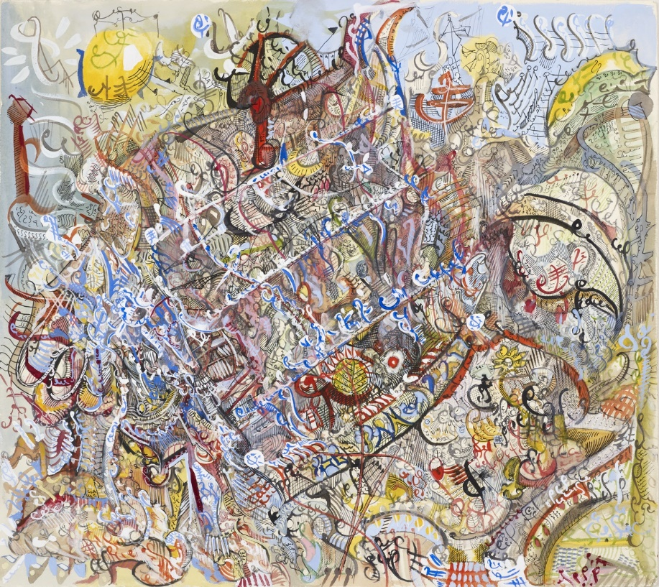
About this opportunity
James Price, Primrose Pathway, Image © the Whitworth, The University of Manchester, Photography by Michael Pollard

Laila Kassab, Love and Passion, from Outside In's collection
Outside In is delighted to be working with the Whitworth in Manchester to deliver a Step Up: Exploring Collections course focusing on their Musgrave Kinley Outsider Art Collection, one of the most significant public collections of Outsider Art in the UK. The course is a great opportunity to gain new skills in research and interpretation whilst getting to know an important collection in a safe and supportive environment.

What is Step Up?
Step Up is the training and professional development programme devised and delivered by award-winning arts charity Outside In. The programme is a key part in the charity’s work to provide a platform for artists who find it difficult to access the art world for reasons including health, disability, social circumstance or isolation. The programme focuses on supporting participants to gain new skills in order to increase opportunities.

Exploring Collections aims to equip participants with skills in research and interpretation. As part of the course, participants are encouraged to find a theme or work from the collection that they would like to focus on, they are then encouraged to produce creative responses to this research.
Tell me more about the Musgrave Kinley Outsider Art Collection…
The Musgrave Kinley Outsider Art Collection consists of over 1,153 individual artworks by over 129 artists, brought together by curator Monika Kinley and gallerist and curator Victor Musgrave over a period of 30 years from 1979 – 2010.

Feeling that most contemporary art was ‘bland and supine in the well-crafted chains of its own making’, Musgrave and Kinley chose instead to seek out and collect artworks that they felt were genuinely original and intuitive: art that ‘tapped into the mains electricity of the imagination.’ These are works by so-called ‘Outsider artists,’ strikingly originally artworks produced by individuals belonging to no movement or school, who are self-taught and marginalised from the ‘mainstream’ art world.

Works in the collection include a Henry Darger triptych, Aloise Corbaz’s ‘Palais Rumine’, Madge Gill’s spiritualist ink drawings, Albert Louden’s pastels, Judith Scott’s woven sculptures and significant works by Pascal Verbena, Scottie Wilson and Carlo Zinelli. The collection was gifted to the Whitworth in 2010 by Monika Kinley and the Trustees of the Musgrave Kinley Outsider Art Collections, facilitated by the Contemporary Art Society.

Tell me more about the course…
The course will be delivered across 10 weeks by an experienced Step Up Course Tutor with involvement from the Whitworth curatorial team, and will take place at the Whitworth in Manchester.

Participants must be able to commit to attending the course on the following dates:

Wednesday 25 January 2023, 11am – 3pm
Wednesday 1 February 2023, 11am – 3pm
Wednesday 8 February 2023, 11am – 3pm
Wednesday 15 February 2023, 11am – 3pm
Wednesday 22 February 2023, 11am – 3pm
Wednesday 1 March 2023, 11am – 3pm
Wednesday 8 March 2023, 11am – 3pm
Wednesday 15 March 2023, 11am – 3pm
Wednesday 22 March 2023, 11am – 3pm
Wednesday 29 March 2023, 11am – 3pm

The course will take place at The Whitworth, Oxford Road, Manchester, M15 6ER

Places on the course are free and Outside In is able to cover reasonable travel expenses.

What do other people say about Step Up?
“A large spark of inspiration into life possibilities, being part of Outside In in general has been amazing for me on this level. It’s like I’m daring to dream of a different life.”

“I think Step Up training with Outside In is an amazing opportunity for any artist to gain real skills and learn and connect with other people in a well-structured, safe and contained, caring way that leaves lots of room for individual interpretation and growth.”

Can I apply?
This course is open to Outside In artists and artists who see themselves as facing a barrier to the art world for reasons including health, disability, social circumstance or isolation. The course will be taking place at the Whitworth, so participants will need to be able to travel there for the sessions (Outside In is able to cover some travel expenses).
How do I apply?
Submissions are made by filling out a short application form, which Outside In is happy to provide in a range of formats. Please highlight any access requirements.

If you have any questions about this course please contact Outside In’s Training Programme Manager, Kate Davey, on 07903 028391 or email kate.davey@outsidein.org.uk.

When do I need to apply by?
Deadline for applications: 9am, Monday 9 January 2023
Following the deadline, we will hold some informal interviews on Zoom to find out more about applicants. We will contact you with dates and times for these, but please let us know in your application if there are dates and times you definitely cannot make.
About the Whitworth
The Whitworth is proudly part of the University of Manchester, operating as a convening space between the University and the people of the city. It was founded in 1889 as The Whitworth Institute and Park in memory of the industrialist Sir Joseph Whitworth for ‘the perpetual gratification of the people of Manchester’ and continues this mission today in new contexts.

The gallery is driven by a mission to work with communities to use art for positive social change, and actively address what matters most in people’s lives. This new vision has been developed as part of an international dialogue about how to evolve and adapt museums to a constantly changing world.

This work is underpinned by three key concepts: Learning together, through making and doing; Creating a place of care, consideration and community; Taking action.
www.whitworth.manchester.ac.uk

About Outside In
Outside In is a catalyst for change. Founded in 2006, it is now an established national charity that aims to provide a platform for artists who face significant barriers to the art world due to health, disability, social circumstance or isolation.
Outside In’s work covers three main areas: Artist development, exhibitions and training. These activities, supported by fundraising and communications, all aim to create a fairer art world by supporting artists, creating opportunities and educating organisations.
Since its inception, Outside In has engaged with more than 5,000 artists traditionally excluded from the mainstream art world, reached a quarter of a million audience members and gained more than 80 partner organisations nationally. It has held more than 50 exhibitions to date and now provides opportunities and support for more than 3,000 artists.
www.outsidein.org.uk

